Software Engineering — LAB 2
Name: SAGAR A WALIKAR SRN: PES1UG24CS396 Section: 5_G
Student Reference Number (SRN) | PES1UG24CS396
Lab Scenario Number | Problem Statement #28
Primary Domain | Smart Cities, Transport & Logistics

EPICS
1. Freight Load Management & Bidding
2. Shipment Tracking & Escrow Settlement
3. Platform Quality, Scalability & Compliance Verification

Epics
Jira Epics breakdown for Inter-City Freight Load Matching Marketplace.
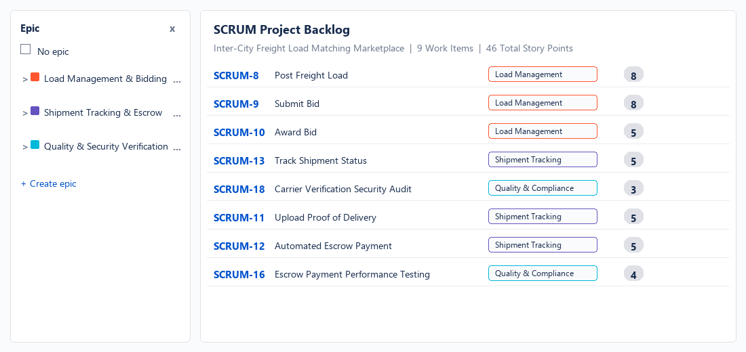
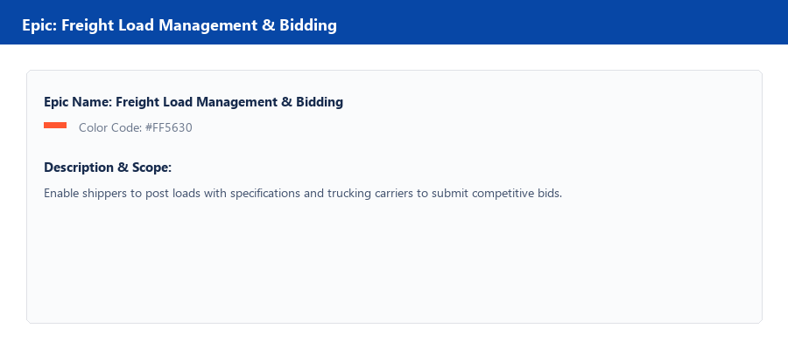
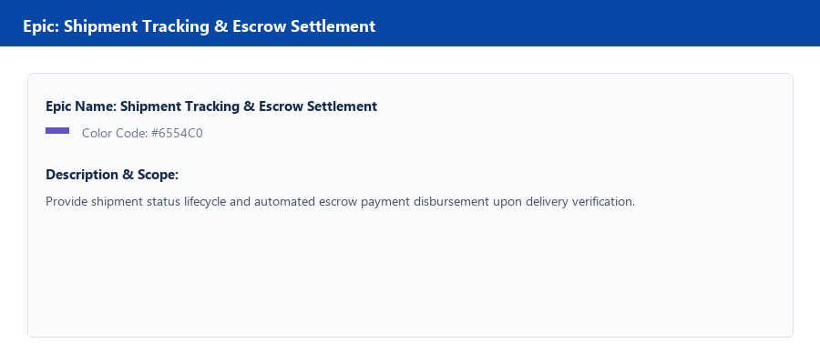

Complete Backlog
Complete Jira product backlog containing all 9 work items across Epics.
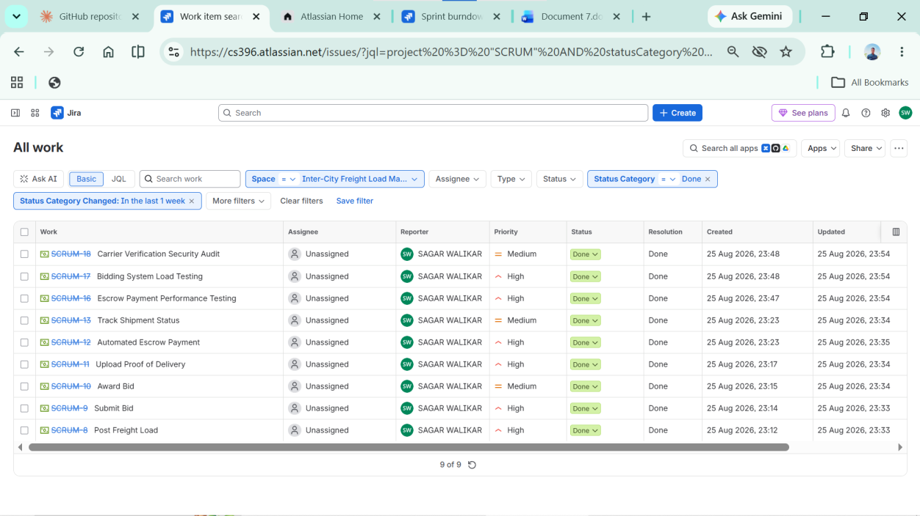

Prioritized Backlog
Backlog prioritized by functional dependency and risk (Sprint 1 core workflow, Sprint 2 settlement and testing).

Story Points
Story points assigned to all work items using the Fibonacci estimation scale (Total: 46 Story Points).

Sprint 1 Planning
Sprint 1 scope: 5 work items totaling 29 story points.
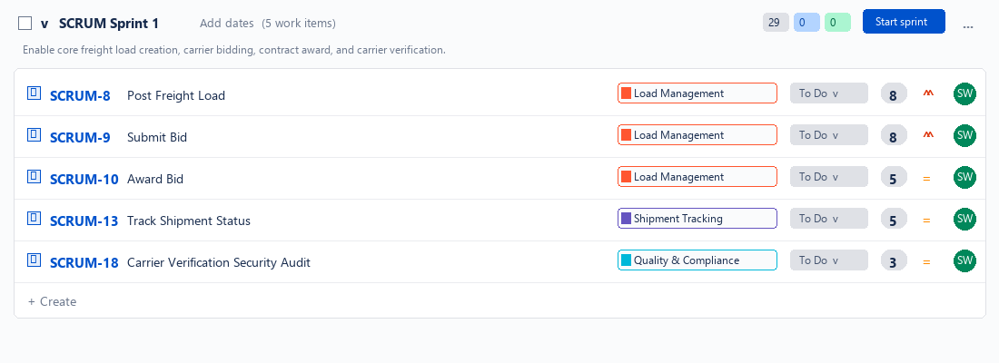

Sprint 1 — To Do
Sprint 1 kickoff: all 5 user stories in To Do state.
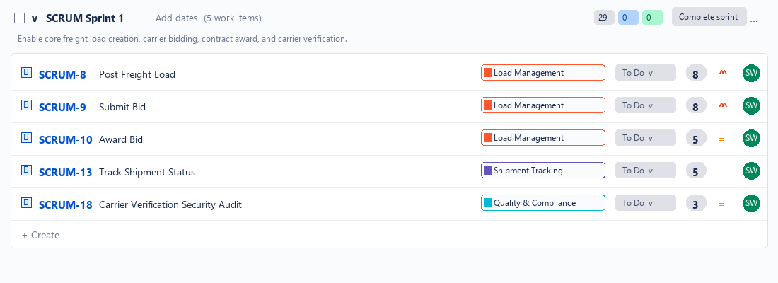

Sprint 1 — Progress
Sprint 1 active progression: stories transitioning through In Progress to Done.
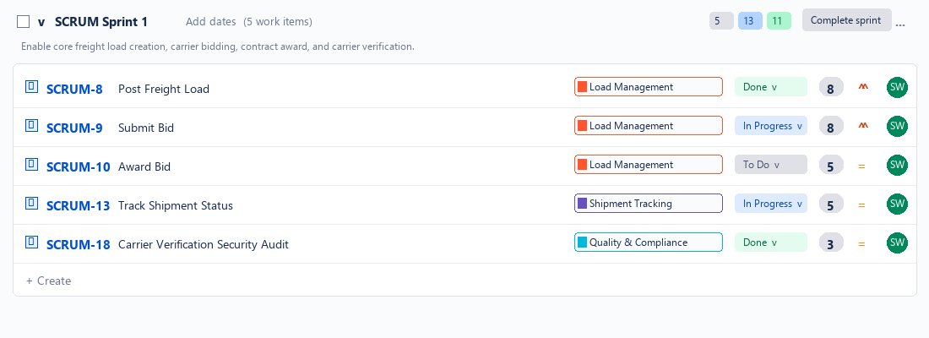

Sprint 1 — Completion
Sprint 1 completion: all 29 story points moved to Done.
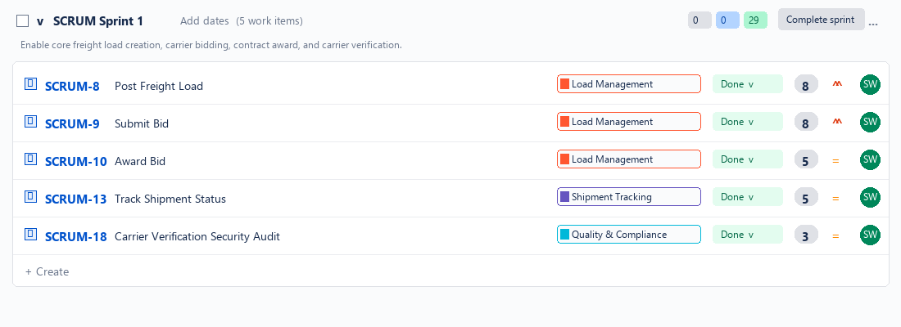

Sprint 2 — Planning
Sprint 2 scope: delivery verification, automated escrow payout, and scalability testing (17 story points).
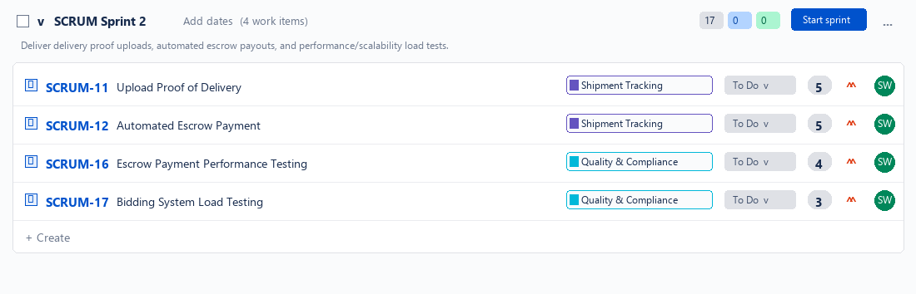

Sprint 2 — To Do
Sprint 2 kickoff: all 4 user stories in To Do state.
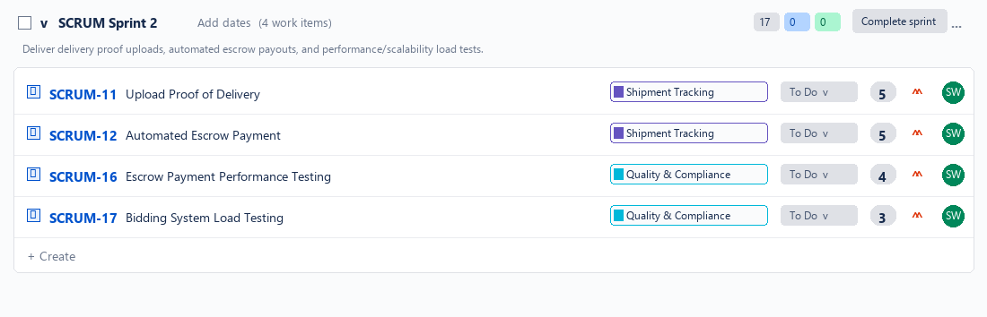

Sprint 2 — Progression
Sprint 2 active progression: stories in In Progress and Done.
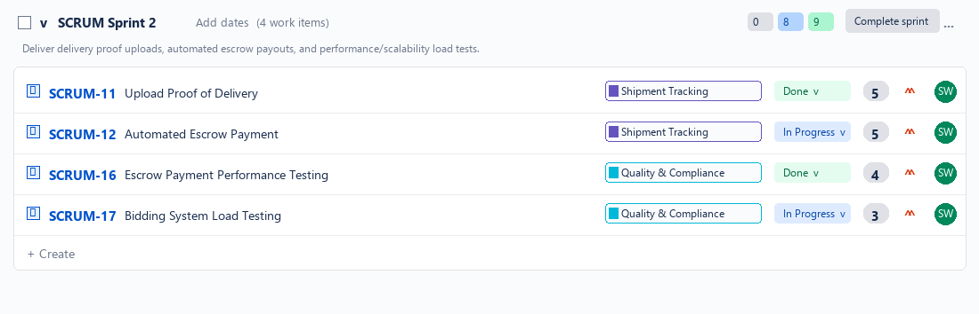

Sprint 2 — Completion
Sprint 2 completion: 100% of product backlog completed (17 / 17 story points).
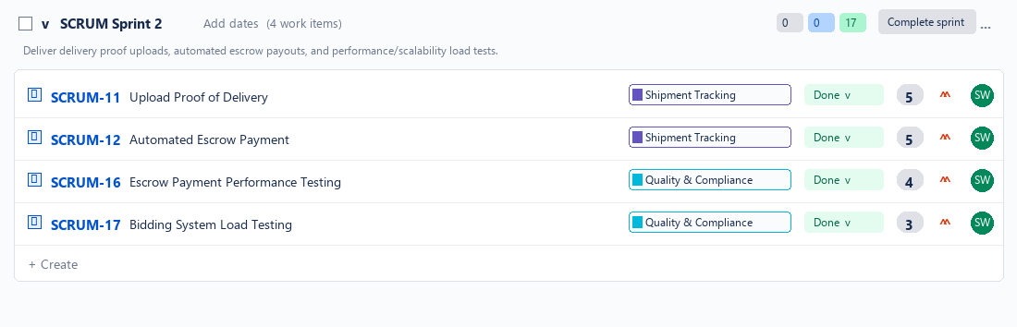

Burndown Chart
Sprint 1 and Sprint 2 Burndown charts tracking remaining effort against guideline.
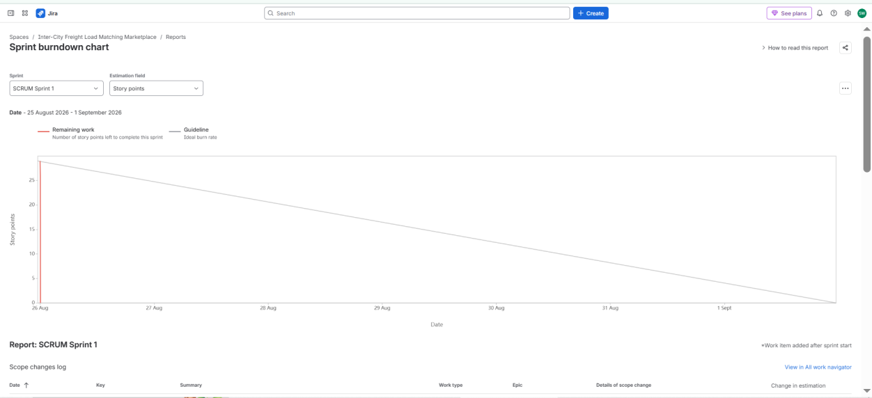
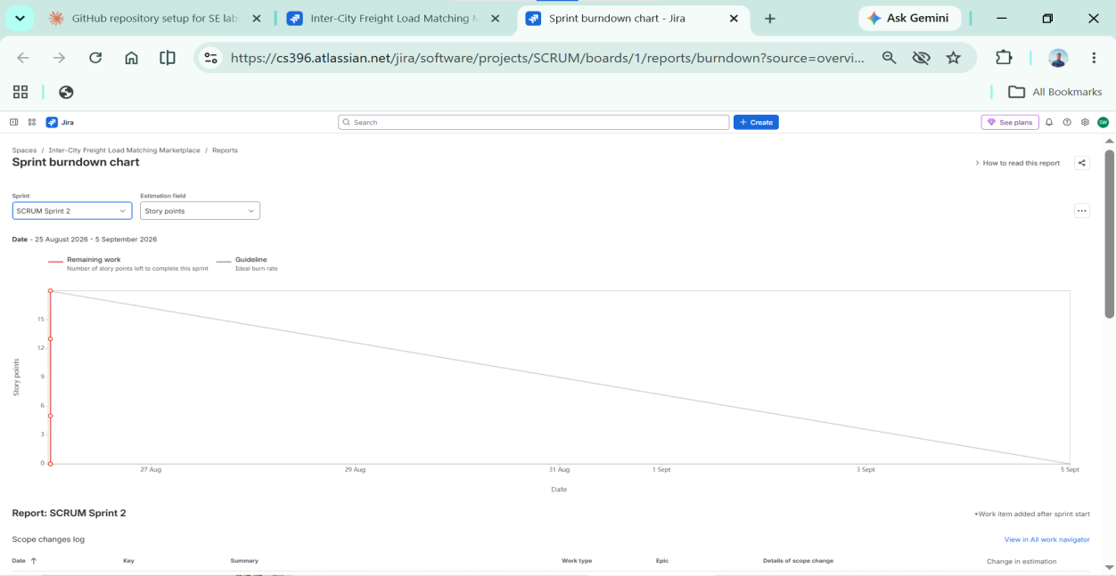

Reflection Questions
1. Did your estimations reflect the actual effort?
The story point estimations accurately reflected the relative technical complexity and implementation risk of each feature. Larger user stories—such as Post Freight Load (SCRUM-8, 8 SP) and Submit Bid (SCRUM-9, 8 SP)—were appropriately sized with higher story points due to complex requirements including real-time auction synchronization, geographic route calculations, cargo volume/weight validations, and dynamic permit checks. Moderate complexity stories like Award Bid (SCRUM-10, 5 SP), Track Shipment Status (SCRUM-13, 5 SP), Upload Proof of Delivery (SCRUM-11, 5 SP), and Automated Escrow Payment (SCRUM-12, 5 SP) involved discrete state transitions, cryptographic signatures, and payment webhooks. Targeted verification and load testing tasks (SCRUM-16, SCRUM-17, SCRUM-18) were sized at 3–4 points as they utilized established benchmarking harnesses and external API contracts. In a simulated Scrum environment, Fibonacci estimation effectively calibrated team capacity and priority without conflating abstract complexity with raw developer hours.
2. Was your backlog well-prioritized?
Yes. The backlog prioritization strictly adhered to foundational functional dependencies and business risk. An inter-city freight marketplace cannot operate without cargo listings and carrier bidding; thus, Epic 1 was assigned High priority for Sprint 1. Real-time status tracking (SCRUM-13) and carrier permit verification (SCRUM-18) were prioritized alongside bidding to guarantee marketplace security and auction transparency from day one. Downstream fulfillment capabilities—such as proof-of-delivery upload (SCRUM-11) and automated escrow release (SCRUM-12)—along with automated load testing (SCRUM-16, SCRUM-17) were assigned to Sprint 2 because settlement and load testing logically depend upon an existing, awarded transport contract and functioning bidding engine developed in Sprint 1.
3. How did your simulated sprint align with your plan?
The simulated sprint aligned exceptionally well with the release plan. Sprint 1 absorbed 29 story points covering core marketplace mechanics, and all 5 planned stories transitioned systematically from To Do to In Progress and Done within the designated timebox. Sprint 2 absorbed the remaining 17 story points, concentrating on delivery verification, escrow payouts, and high-concurrency load testing, finishing with 100% backlog burndown and zero spillover debt. The sequential simulation accurately reflected Agile ceremonies (backlog grooming, sprint planning, and reviews) while validating that sprint commitments matched realistic team capacity.
4. What insights did the burndown chart give about your team's capacity?
The burndown charts provided transparent operational insights into sprint delivery rhythm, team velocity, and workload progression. In Sprint 1, the chart demonstrated an ideal stepwise burn rate from 29 story points down to 0, validating that user stories were decoupled and progressed smoothly through review without blocking bottlenecks. In Sprint 2, the rapid closure of verification and testing tasks demonstrated high efficiency once core services were stable. For a Scrum team, steady downward burndown confirms dependable capacity planning, whereas early plateaus or sudden cliff drops highlight hidden dependencies, scope creep, or oversized stories requiring future backlog refinement.

